**CHAPTER 1**

**INTRODUCTION**

* 1. **Temple Management**

Temple Management Package is a highly scalable product for Hindu Temples. It offers a complete automation in billing and accounts, inventory, staff management and administration sections .Temple Management solution is bundled with an excellent accounting package which enables easy operation and efficient reporting. It's available with internet support to allow devotees to make online offerings, pooja bookings, and many more useful features.

The development of portal for places of worship generally means creating a website in which the management of all functions and activities of temples is done by the administrator where all people (viewers) can view and know all the relevant information about the places of worship which they seek. The website consists of basic pages from which the user can navigate to view and know the relevant information like history, pooja timing of all temples, information about upcoming festivals, donation and expenditure of all temples, the photos of all temples, and the committee members of temple management and also can give feedback for management these places of worship.

In order to understand the concept of management of temples, a survey of relevant literature was conducted. Books written by authors were helpful in identifying the evolution of Hindu temple worship and its administration. A few books by historians and ethnographers helped in identifying the sources of data for the study. The available literature is related the development of temples worship and its administration and management.

The book provides information on how the practices of worship in temples got institutionalized during the periods of different monarchs. The author has examined the role of priests in the development of temple worship. The book gives an overview of the growth of temple worship in India.

**CHAPTER 2**

**REQUIREMENT SPECIFICATION**

**2.1 Goals of Implementation**

The implementation of the system provides a portal which will also provide an easy and good

Looking user interface for which the end user can view and search the required information from

the system. In our case, the end user can know the temple history, the puja timings of temples, the special events of the temples, the festivals details, the committee member’s details of places of worship, the donation and expenditure of the temples per year or can search as per their date

Interval. End users can also give feedback for these temples.

**2.2 FUNCTIONAL REQUIREMENTS**

For documenting the functional requirements, the set of functionalities supported by the system are be specified. In our system, basically the management parts are the functional requirements which are donation and expenditure. Like donation, in expenditure, the administrator inputs the expenditure details (Voucher no, date of expenditure, for which purpose expenditure is done, amount of expenditure) and the end user can view the details of the expenditure.

**2.3 NON-FUNCTIONAL REQUIREMENTS**

These are the requirements that are not functional in nature. Especially these are the constraints

the system must work within.

• Performance Requirements: The system response time must be less than 10 seconds for

the user interface. The system must processes the number of transaction based on the

following calculation method.

• Reliability Requirements: The system shall have a minimum uptime of 99 % excluding

time pre-scheduled for maintenance and/or upgrades.

**2.4 HARDWARE AND SOFTWARE REQUIREMENTS**

The hardware requirements of our project are:

### Pentium IV Processor or above

### 128 MB RAM.

### 20GB Hard Disk space.

The software requirements of our project are:

Operating System : Windows 10

Back End : SQL SERVER-2008

Front End : Notepad++

Database Connectivity : PHP

Server : Microsoft SQL Server-2012

**2.5 SOFTWARE TOOLS USED**

The whole project is divided into two parts, namely, front end and the back end.

**2.5.1 Front End:**



The front end is designed using Notepad++. It  is a text editor and source code editor for use with Microsoft Windows. It supports tabbed editing, which allows working with multiple open files in a single window. The project's name comes from the C increment operator.

Notepad++ is distributed as free software. At first the project was hosted on SourceForge.net, from where it has been downloaded over 28 million times, and twice won the SourceForge Community Choice Award for Best Developer Tool.The project was hosted on TuxFamily [[fr](https://fr.wikipedia.org/wiki/TuxFamily)] from 2010 to 2015; since 2015 Notepad++ has been hosted on GitHub. Notepad++ uses the Scintilla editor component.

**2.5.2 Back End:**

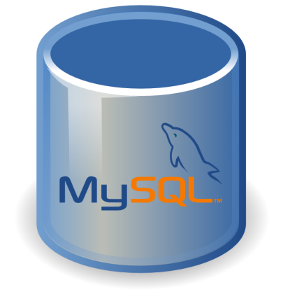

The back end is designed using MySQL Server.

MySQL is an open source relational database management system where “SQL” ,the abbreviation for Structured Query Language . SQL is the most popular language for adding, accessing and managing content in database.

* ***Microsoft SQL is a database management system.***

A database is a structured collection of data. It may be anything from a simple shopping list to a picture gallery or the vast amounts of information in a corporate network. To add, access, and process data stored in a computer database, you need a database management system such as Microsoft SQL Server. Since computers are very good at handling large amounts of data, database management systems play a central role in computing, as standalone utilities, or as parts of other applications.

* ***Microsoft SQL databases are relational.***

A relational database stores data in separate tables rather than putting all the data in one big storeroom. The database structures are organized into physical files optimized for speed. The logical model, with objects such as databases, tables, views, rows, and columns, offers a flexible programming environment. You set up rules governing the relationships between different data fields, such as one-to-one, one-to-many, unique, required or optional, and “pointers” between different tables. The database enforces these rules, so that with a well-designed database, your application never sees inconsistent, duplicate, orphan, out-of-date, or missing data.

The SQL part of “Microsoft SQL” stands for “Structured Query Language”. SQL is the most common standardized language used to access databases. Depending on your programming environment, you might enter SQL directly (for example, to generate reports), embed SQL statements into code written in another language, or use a language-specific API that hides the SQL syntax.

* ***Microsoft SQL software is Open Source.***

Open Source means that it is possible for anyone to use and modify the software. Anybody can download the MySQL software from the Internet and use it without paying anything. If you wish, you may study the source code and change it to suit your needs. The Microsoft SQL software uses the GPL (GNU General Public License). If you feel uncomfortable with the GPL or need to embed Microsoft SQL code into a commercial application, you can buy a commercially licensed version.

* ***The Microsoft SQL Database Server is very fast, reliable, scalable, and easy to use.***

If that is what you are looking for, you should give it a try. Microsoft SQL Server can run comfortably on a desktop or laptop, alongside your other applications, web servers, and so on, requiring little or no attention. If you dedicate an entire machine to Microsoft SQL, you can adjust the settings to take advantage of all the memory, CPU power, and I/O capacity available. Microsoft SQL can also scale up to clusters of machines, networked together.

Microsoft SQL Server was originally developed to handle large databases much faster than existing solutions and has been successfully used in highly demanding production environments for several years. Although under constant development, Microsoft SQL Server today offers a rich and useful set of functions. Its connectivity, speed, and security make Microsoft SQL Server highly suited for accessing databases on the Internet.

* ***Microsoft SQL Server works in client/server or embedded systems.***

The Microsoft SQL Database Software is a client/server system that consists of a multi-threaded SQL server that supports different back ends, several different client programs and libraries, administrative tools, and a wide range of application programming interfaces (APIs).

We also provide MySQL Server as an embedded multi-threaded library that you can link into your application to get a smaller, faster, easier-to-manage standalone product.

**CHAPTER 3**

**DATABASE DESIGN**

**3.1 Design**

The purpose of design phase a solution of the problem specified in the requirement document. This is the first step in moving from the problems domain to the solution domain. The design of the system is perhaps the most critical factor affecting the quality of the software. It has a major impact on the later phases in the design document.

**3.2 ENTITY RELATIONSHIP DIAGRAM**

An entity–relationship model (or ER model) describes interrelated things of interest in a specific domain of knowledge. A basic ER model is composed of entity types (which classify the things of interest) and specifies relationships that can exist between entities (instances of those entity types).

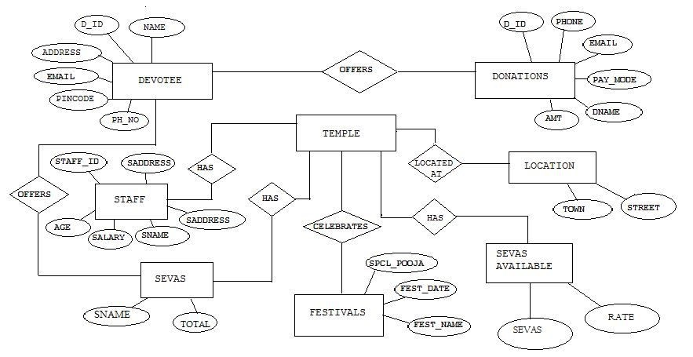

Figure 3.1: ER Diagram

**CHAPTER 4**

**SYSTEM DESIGN**

**4.1 TABLE DESIGN**

The project requires many relations to store the data and retrieve it. These relations are defined as tables in SQL using CREATE TABLE statement. The following are the tables defined in our project.

●DEVOTEE Table to store Devotee information

CREATE TABLE DEVOTEE DETALS (

D_ID INTEGER PRIMARY KEY,

NAME VARCHAR(20),

PHONE_NO BIGINT(10),

ADDRESS VARCHAR(20),

EMAIL_ID VARCHAR(20),

TEMPLE_NAME VARCHAR(20) );

●DONATION Table to store Donation information

CREATE TABLE DONATION DETALS (

DONAR_ID INTEGER PRIMARY KEY,

DONOR_NAME VARCHAR(20),

ADDRESS VARCHAR(20),

PHONE_NO BIGINT(10),

AMOUNT INTEGER,

PAYMENT_MODE VARCHAR(20),

TEMPLE_NAME VARCHAR(20) );

●STAFF Table to store Staff information

CREATE TABLE STAFF DETALS (

STAFF_ID INTEGER PRIMARY KEY,

NAME VARCHAR(20),

AGE INTEGER,

ADDRESS VARCHAR(20),

WORKS_AS VARCHAR(20),

SALARY FLOAT,

TEMPLE_NAME VARCHAR(20) );

●COMMITTEE Table to store Committee information

CREATE TABLE COMMITEE DETALS (

C_ID INTEGER PRIMARY KEY,

NAME VARCHAR(20),

AGE INTEGER,

DESIGNATION VARCHAR(20),

ADDRESS VARCHAR(20),

PHONE_NO BIGINT(10),

TEMPLE_NAME VARCHAR(20) );

●FESTIVAL Table to store Festival information

CREATE TABLE FESTIVALS DETALS (

FESTIVAL_ID INTEGER PRIMARY KEY,

FESTIVAL_NAME VARCHAR(20),

FESTIVAL_DATE DATE,

SPECIAL_POOJA VARCHAR(20),

TEMPLE_NAME VARCHAR(20) );

●SEVAS Table to store Seva information

CREATE TABLE SEVAS_AVAILABLE (

SEVA_NAME VARCHAR(20),

RATE INTEGER,

TEMPLE_NAME VARCHAR(20) );

**CHAPTER 5**

**SYSTEM TESTING**

The aim of the system testing process was to determine all defects in our project. The program was subjected to a set of test inputs and various observations were made and based on these observations it will be decided whether the program behaves as expected or not.

**5.1 UNIT TESTING**

Unit testing is undertaken when a module has been created and successfully reviewed. In order to test a single module, we need to provide a complete environment where-in besides the module we would require

* The procedures belonging to other modules that the module under test calls
* Non-local data structures that module access
* A procedure to call the functions of the module under test with appropriate parameters

Unit testing was done on each and every module that is described under form design description.

● Test For the admin module:

* Testing admin login form-This form is used for log in of administrator of the system. In this we enter the username and password if both are correct administration page will open otherwise if any of data is wrong it will give an error message.

**CHAPTER 6**

**Materials and Methodology**

**6.1 Methodology**

In general, methodology follows the following phases:

1. The current system is evaluated. Insufficiencies are documented. This can be done by

interviewing users of the system and referring with support people.

2. The new system requirements are defined. In particular, the insufficiencies in the present system must be addressed with specific proposals for development.

3. The proposed system is considered. Plans are laid out concerning the physical structure, hardware, operating systems, programming, communications, and security issues.

4. The new system is developed. The new components and programs must be acquired and installed. Users of the system must be expert in its use, and all aspects of performance must be verified. If necessary, adjustments must be made at this stage.

**CHAPTER 7**

**RESULT**

**Login page**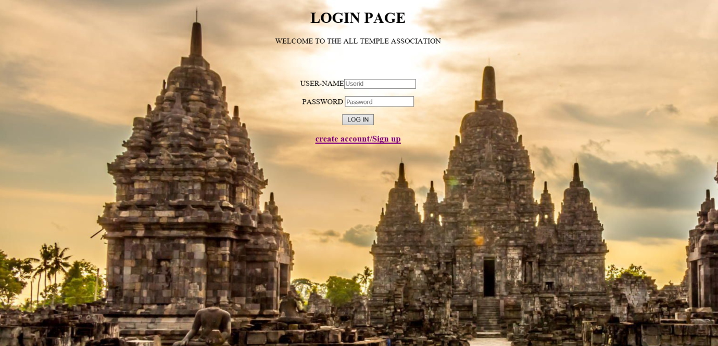

Figure 7.1: Login page

User authentication is very common in modern web application. It is a security mechanism that is used to restrict unauthorized access to member-only areas and tools on a site.

Where normal user can login into this page user can register if his/her account does not exist. After he got register into login page he will get username and password using which he can login into the page. In order to see the information about the Devotee, Committee, Sevas etc

**SIGN UP PAGE**

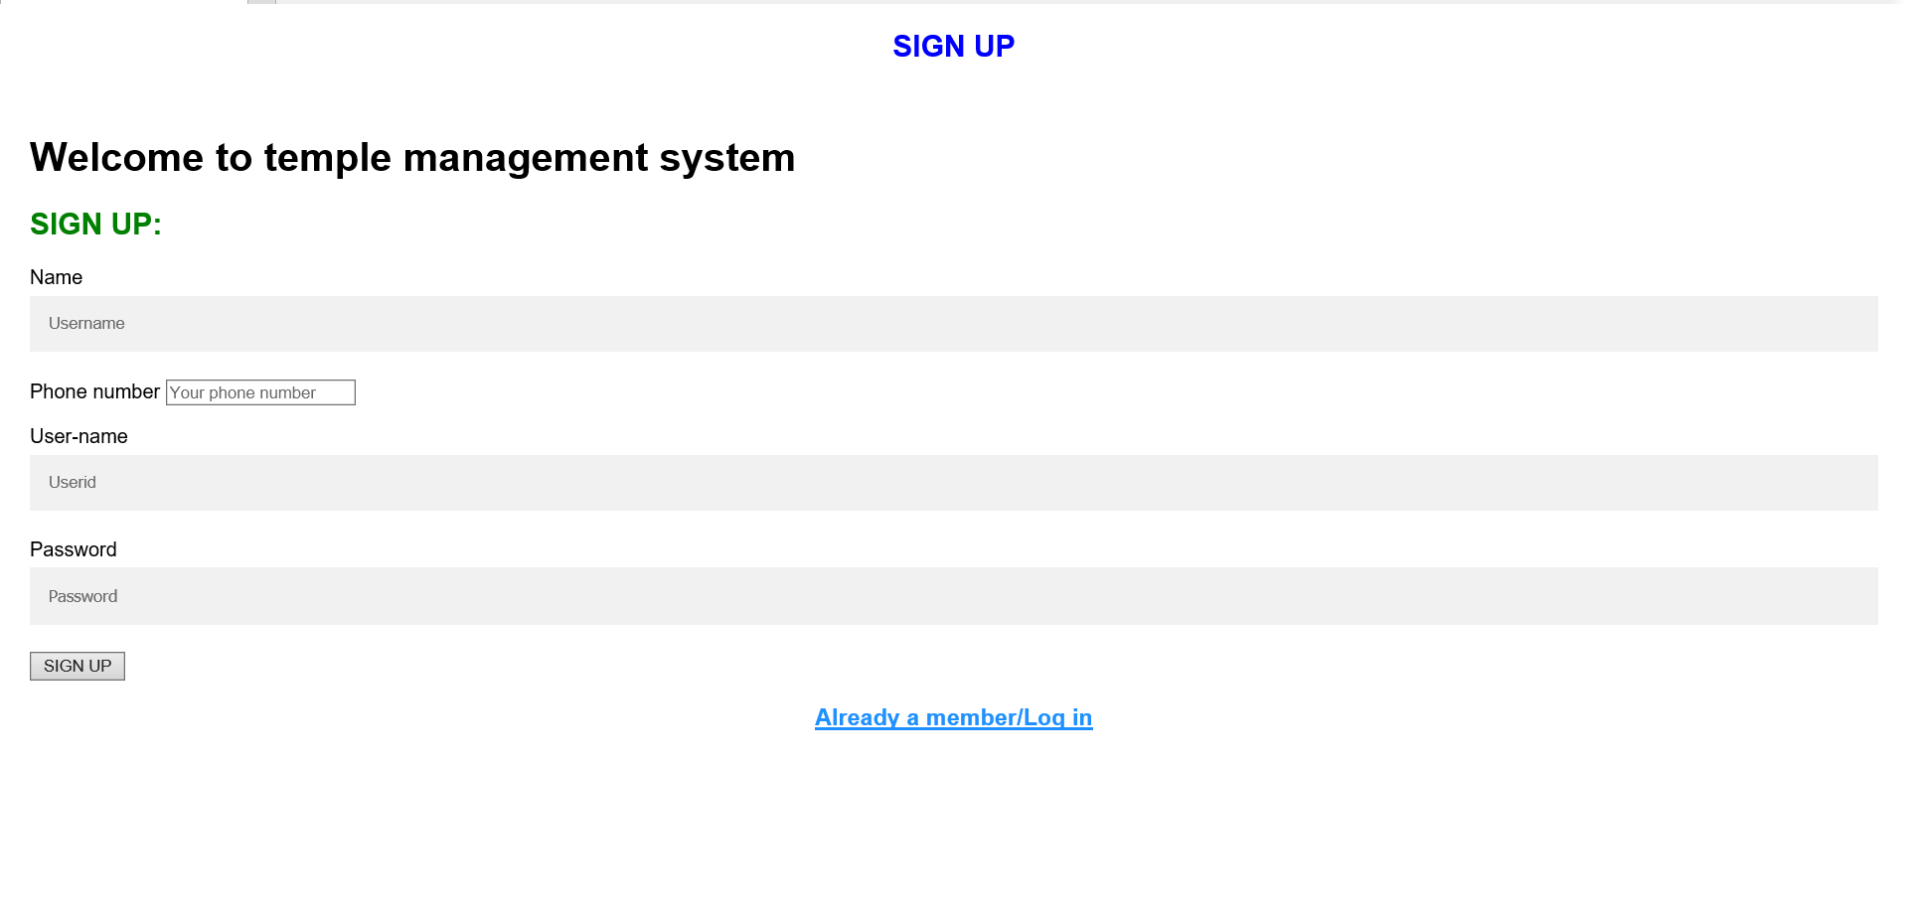

Figure 7.2: sign up

This page is used to sign up for the new users who want to know the various information about the temple. You can sign up by entering new user name and password.

**Information Management**

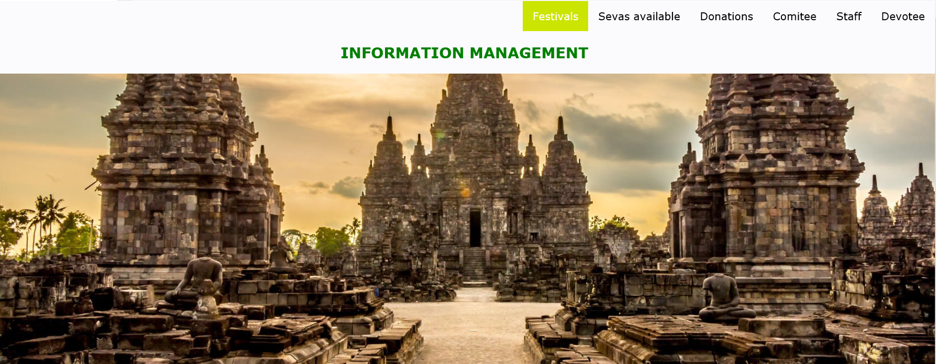

Figure 7.3: Information management

From this module normal user can view details of the Devotee, Committee, Sevas Available, Staff, Donations, Festivals Information.

Information management (IM) concerns a cycle of organizational activity: the acquisition of information from one or more sources, the custodianship and the distribution of that information to those who need it, and its ultimate disposition through archiving or deletion.

Information management is closely related to, and overlaps with, the management of data,

System, technology and processes.

**Devotee Details**

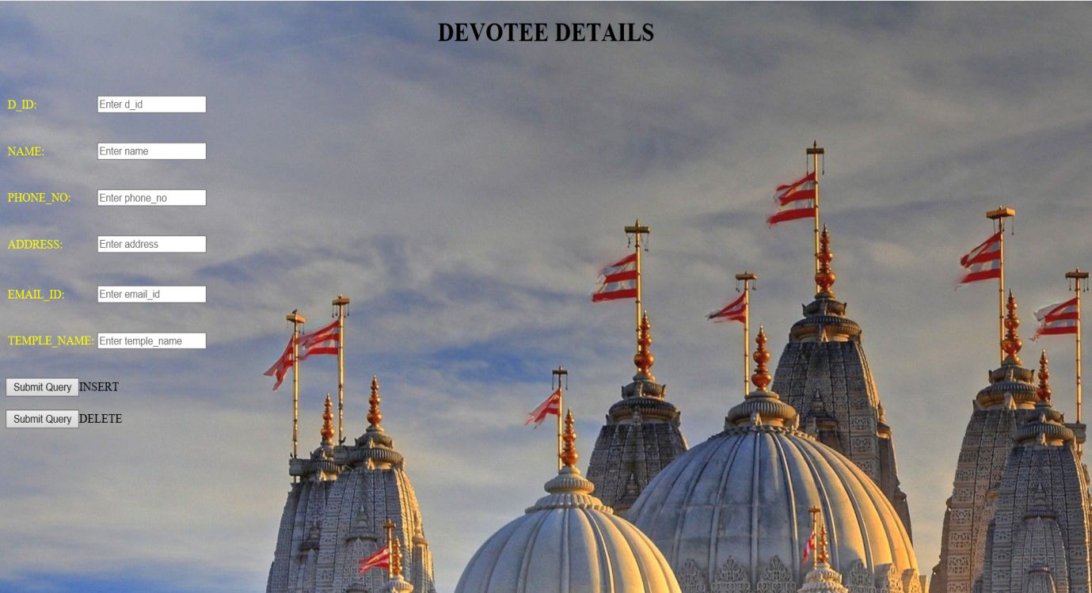

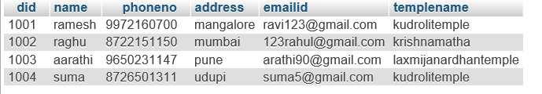

Figure 7.4: Devotee details

Devotees of Temple can be managed with the help of this module as, Entry of new devotee with their detail d_id, name, address, email_id & contact Information can be done through this module, and information will be stored in data base for further use & avoid duplication

.

**Donation Details**

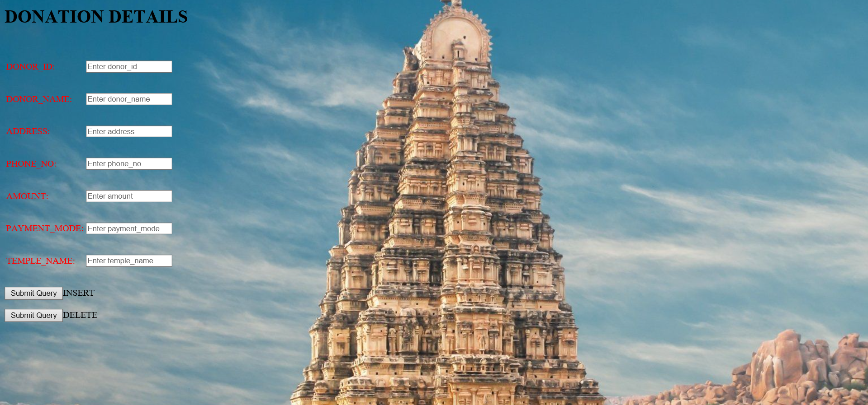

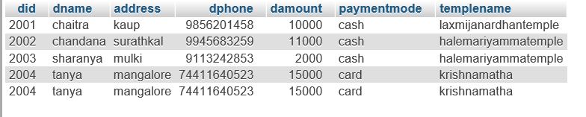

Figure 7.5: Donation details

Donation of temple can be managed through this module, where every kind of donation either related to management or any temple activity can be entered here & vouchers related to those particular expenses can be generated with print.

**Staff Details**

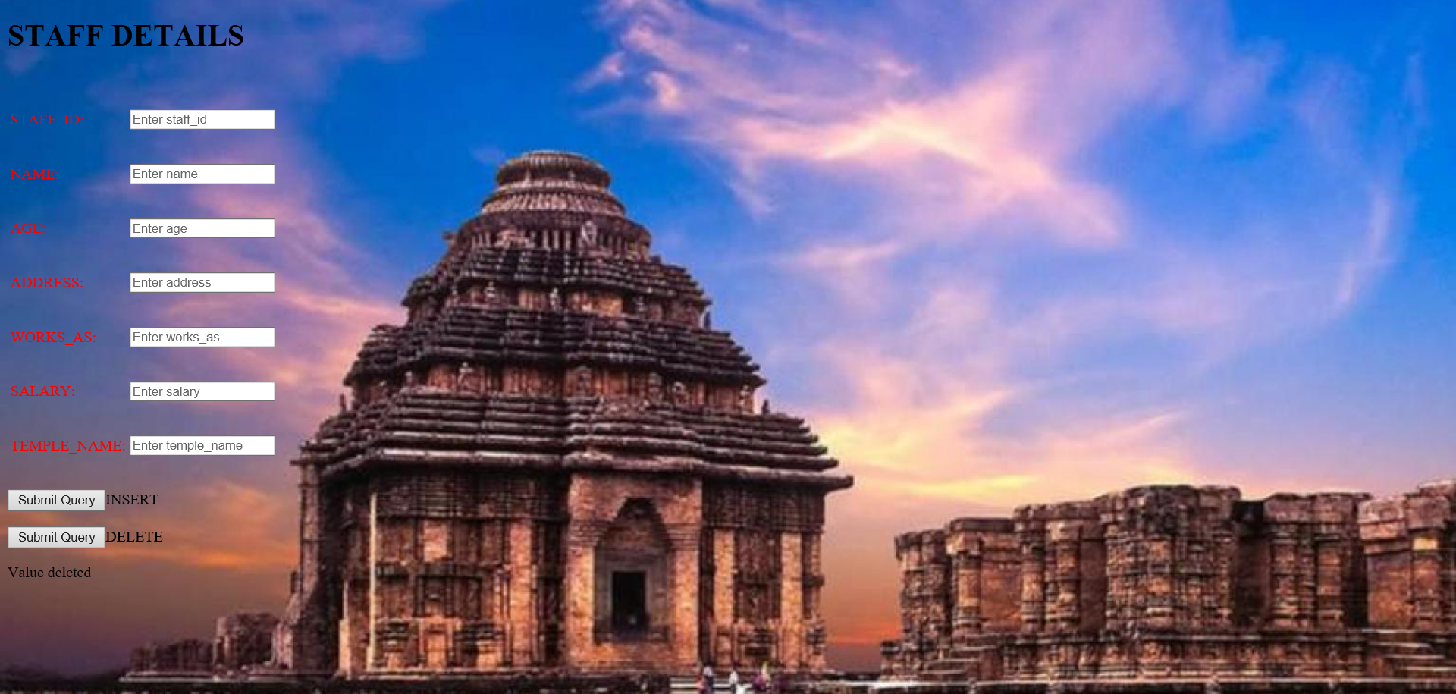

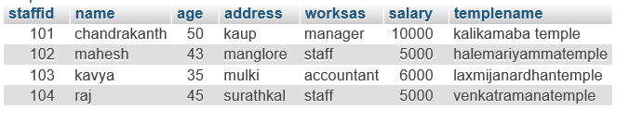

Figure 7.6: Staff details

Staff Details of Temple can be managed with the help of this module as, staff_id, name, address, age, works on, salary done through this module, and information will be stored in data base for further use & avoid duplication

**Committee Details**

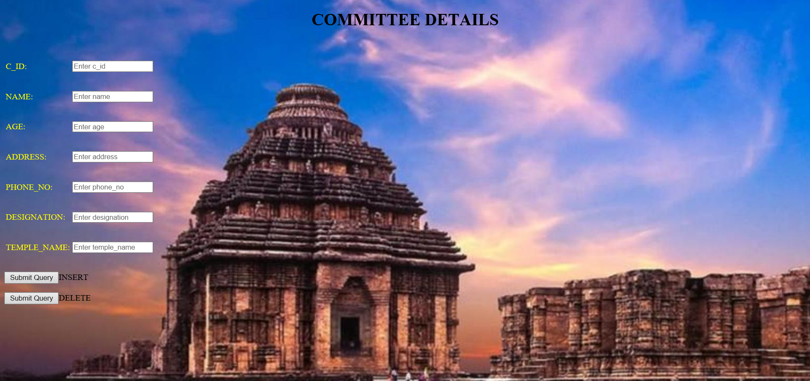

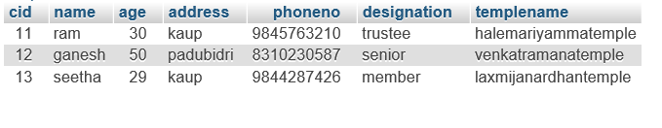Figure 7.7: Committee details

Committee of Temple can be managed with the help of this module as, With their detail c_id ,name ,age ,designation & contact Information can be done through this module, and information will be stored in data base and we can update delete and insert to this table.

**Festivals**

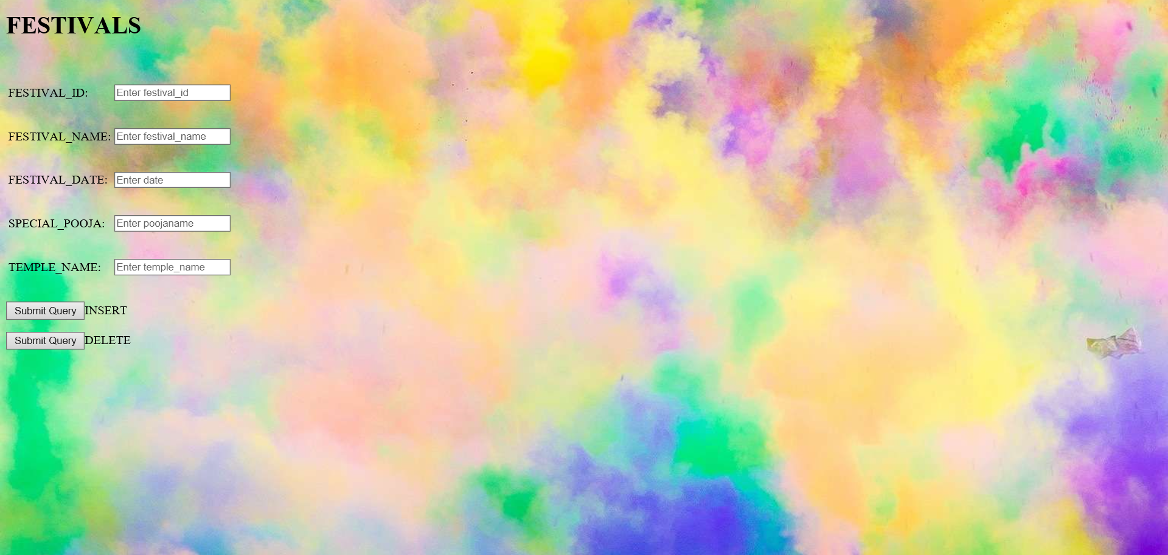

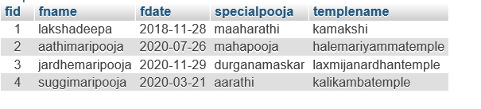 Figure 7.8: Festivals details

Festival of Temple can be managed with the help of this module as, Entry festival name with their detail like festival_id, festival_name ,festival_date ,special pooja can be done through this module, we can insert, delete and update the information.

Festivals often serve to fulfill specific communal purposes, especially in regard to commemoration or thanking to the gods and goddesses. Celebrations offer a sense of belonging for religious, social, or geographical groups, contributing to group cohesiveness. They may also provide entertainment, which was particularly important to local communities before the advent of mass-produced entertainment. Festivals that focus on cultural or ethnic topics also seek to inform community members of their traditions; the involvement of elders sharing stories and experience provides a means for unity among families.

**Sevas Available**

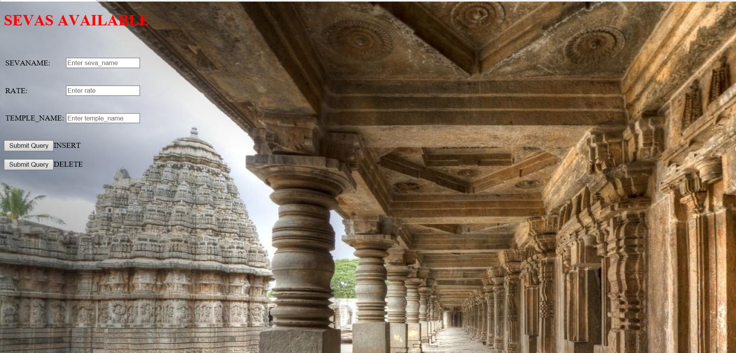 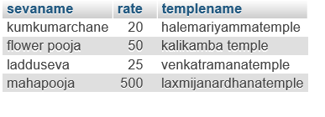

Figure 7.9: Sevas Available

Here are the sevas available and festival insertion view,where we can insert the table sevas available and festivals.

**Chapter 8**

**Conclusions and Future Working**

SQL server and .NET technology Allows to add multiple computers (data entry points) without more investment. Complete agile development Practice ensures delivery of perfect software. Most of the customization will be done at the client premises. This enables clients to make changes during the time of development.

**8.1 Scope for future enhancement**

* Web based On-Line or Counter based Pooja Booking software with payment gateway integration. Date and time slot selection, repeat frequency, Booking on special days is possible. The back office shows activity in real time and generates variety of end of the day reports that even help plan procurement, duty allocation and manpower management.
* Prepaid cards for Cashless environment do away with the hassles of handling cash, soiled, counterfeit and torn notes as well as change. Cash handling can be centralized for ease of management.

**BIBILIOGRAPHY**

[1] Ramez Elmasri, Shamakant Navathe, Fundamentals of Database Systems, 7th edition, Pearson Education, 2017.

**[2]** <https://www.geeksforgeeks.org>

**[3]** <https://www.w3schools.com/>